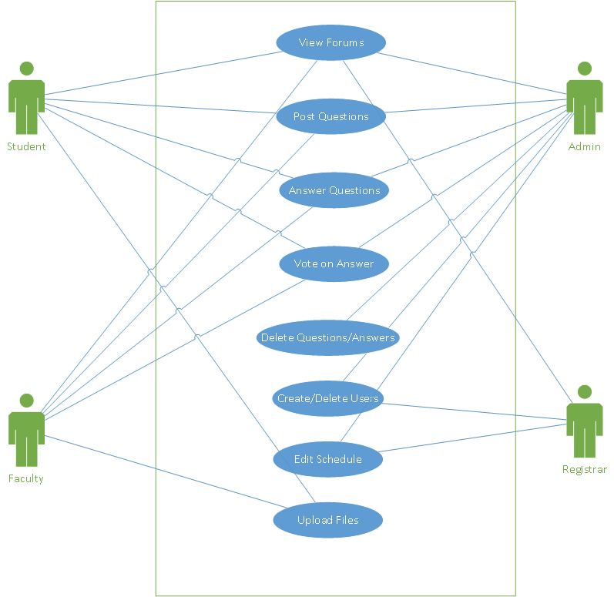

**Use Case UC1: View Forums**

Primary actors: Student, faculty, admin, and registrar

Stakeholders and Interests:

1. Student: Wants to view questions posted in forums
2. Faculty: Wants to view questions posted in forums
3. Admin: Wants to view questions posted in forums
4. Registrar: Wants to view questions posted in forums

Preconditions: Questions must be posted in forum to view; user registered in system

Post conditions: Can view questions in the forum.

Summary: Students, faculty, admin, and registrars can view questions that are posted in the forums

Basic Flow:

1. User logs into system to access
2. User selects question to view
3. System directs the user to the corresponding forum page

Alternate Flow:

1. User unable to sign in
   1. Ensure log in credentials are correct
   2. If password forgotten, request to reset password

3. Page not found (404)

a. Alert user and redirect to homepage

b. Notify admin about the broken link

**Use Case UC2: Post Questions**

Primary actors: Students, faculty, and admin

Stakeholders and Interests:

1. Students: Want to view and ask questions posted in the forums
2. Faculty: Want to view and ask questions posted in the forums
3. Admin: Want to view and ask questions posted in the forums for testing functionality

Preconditions: Must have proper permissions to ask questions.

Post conditions: Question forum started; other users can comment/answer the question

Summary: Students, faculty, and admin will be able to ask questions in the forums

Basic Flow:

1. User logs in
2. Select post new question
3. Submit question

Alternate Flow:

1. User does not have permission to post question
   1. System notifies user and redirects to homepage
2. Error processing the request
   1. System notifies user and refreshes the page to try again

**Use Case UC3: Answer Questions**

Primary actors: Students, faculty, admin

Stakeholders and Interests:

1. Students: Want to view and answer questions posted in the forums
2. Faculty: Want to view and answer questions posted in the forums
3. Admin: Want to view and answer questions posted in the forums

Preconditions: Questions must be posted in the forum to answer, must have proper permissions to answer questions.

Post conditions: User answers the question.

Summary: Students, faculty, and admin will be able to answer questions in the forums to be voted upon.

Basic Flow:

1. User logs in
2. Selects question to answer
3. Posts a new answer to the question

Alternate Flow:

3a. User does not have the proper permissions to answer the question

a. System notifies users and redirects to homepage

3b. Error processing answer

a. System notifies user and refreshes the page to try again

**Use Case UC4: Vote on Answer**

Primary actors: Students, faculty, and admin

Stakeholders and Interests:

1. Students: Can up vote or down vote questions and answers
2. Faculty: Can up vote or down vote questions and answers
3. Admin: Can up vote or down vote questions and answers to test system functionality

Preconditions: Questions must be posted in forum to vote on, must have proper permissions to vote on questions and answers.

Post conditions: Answer is voted upon once but can be changed

Summary: Students, faculty, and admin can vote on answers.

Basic Flow:

1. User logs in
2. Selects question to view
3. Upvote/Downvote specific answers

Alternate Flow:

3. Tries to vote multiple times on same answer

a. Alerts user that answer can be voted upon once, but can be changed from upvote to downvote or vice versa

**Use Case UC5: Delete Questions and Answers**

Primary actor: Admin

Stakeholders and Interests:

1. Admin: Can delete questions and answers if they are deemed inappropriate

Preconditions: Must be admin to delete questions and answers

Post conditions: Admin can delete questions and answers they deem inappropriate.

Summary: Admin will determine if questions and answers are appropriate to be posted to the forum.

Basic Flow:

1. User logs in
2. Selects inappropriate question/answer to edit/delete
3. Edits/deletes question/answer

Alternate Flow:

1. Not admin user

* 1. System redirects and notifies user that they do not have the proper permissions to edit/delete posts.

3. Can’t process request

a. Notifies user and refreshes page to try again

**Use Case UC6: Create and Delete Users**

Primary actors: Admin and registrar

Stakeholders and Interests:

1. Admin: Can create and remove users
2. Registrar: Can create and remove users

Preconditions: Must be Admin or registrar to create and remove users; new user must not exist in system already

Post conditions: Can create and remove users

Summary: Admin and registrar can create and remove users

Basic Flow:

1. User logs in
2. Select to create a new user
3. Attempt to create new user if does not already exist in system
4. New user is created

Alternate Flow:

1. User does not have permissions to create new users

* 1. System redirects to homepage and alerts user they do not have proper permissions

3. User already in system

1. System notifies user that the user already exists in the system and cancels request

4. Cannot process request

a. System notifies user and refreshes page to try again

**Use Case UC7: Edit Schedule**

Primary actors: Admin and registrar

Stakeholders and Interests:

1. Admin: Can edit the students/faculty schedule
2. Registrar: Can edit the students/faculty schedule

Preconditions: Must be admin or registrar to edit schedules.

Post conditions: Semester schedules updated

Summary: Admin and registrar can edit the schedules of students/faculty for the current semester

Basic Flow:

1. User logs in
2. Navigates to the edit schedule page
3. Submit form to edit the schedule

Alternate Flow:

1. User does not have permissions to edit schedules

* 1. System notifies user and redirects to homepage

3. Cannot process form

a. System notifies user and refreshes page to try again

**Use Case UC8: Upload Files**

Primary actors: Student and Faculty

Stakeholders and Interests:

1. Students: can upload educational materials (diagrams/tutorials) to profile
2. Faculty: can upload educational materials (diagrams/tutorials) to profile

Preconditions: Must be student or faculty to have an individual profile in order to upload files to said profile.

Post conditions: Files uploaded to profile

Summary: Students and faculty can upload pertinent educational materials to their profile for public viewing

Basic Flow:

1. User logs in
2. Navigates to individual profile
3. Select to upload a file
4. Select file to upload
5. File uploaded and added to profile

Alternate Flow:

2. User does not have proper permissions to have a profile

a. System notifies user they cannot have a profile

3a. File not acceptable format

1. Request cancelled and user notified

3b. File size too large

a. User notified and prompted to select a different file